# User manual

1. Welcome Page

1. Log In Page

You could choose three different ways to log in.

2.1 Log In By ID number

Click “Booking Number”, input your **booking number** to log in.

If your booking number is wrong, the “Wrong booking number !” box will pop up

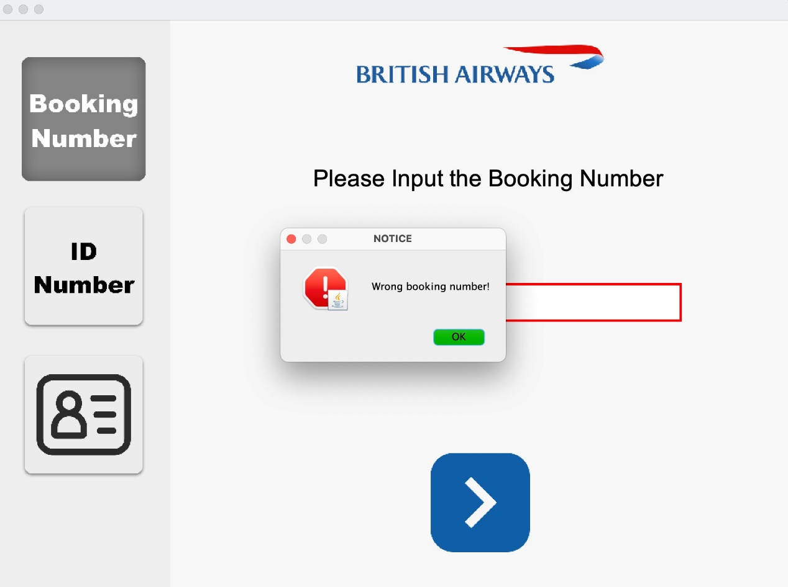

2.2 Log In By ID Number

Click “ID Number”, input your **surname** and **ID number** to log in.

If your surname or ID number is wrong, the “Wrong surname or ID number!” box will pop up

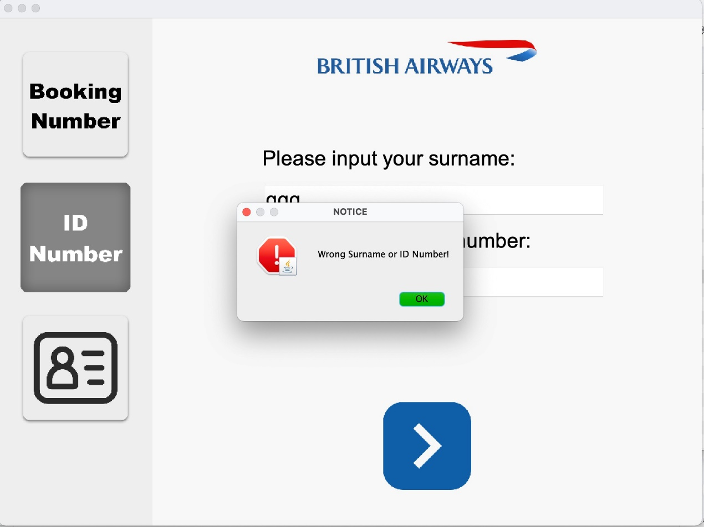

2.3 Log In By ID Card

Click picture of “ ID Card “, you could log in by scanning your ID card

If your ID card is valid, the ”legal information.” box will pop up

1. Display Information

* The information such as departure places, destination, flightNo will be displayed in this page, the user could check the information.
* Click “HOME”, go back to “Welcome Page”
* Click “BACK”, go back to the previous page图形用户界面, 文本, 应用程序, 聊天或短信

  描述已自动生成
* Click “NEXT”, next step

4.Seat Option

4.1 First class

Blue means available. Yellow is a more spacious seat worth fifty pounds while the grey seat has been chosen by other passengers. After completing your seat selection your seat will be shown in green.

4.2 Business class

Blue means available. Yellow is a more spacious seat worth fifty pounds while the grey seat has been chosen by other passengers. After completing your seat selection your seat will be shown in green.

4.3 Economic class

Blue means available. Yellow is a more spacious seat worth fifty pounds while the grey seat has been chosen by other passengers. After completing your seat selection your seat will be shown in green.图片包含 气泡图

If you do not select a seat, a notice will pop up and you will not be able to enter the next screen.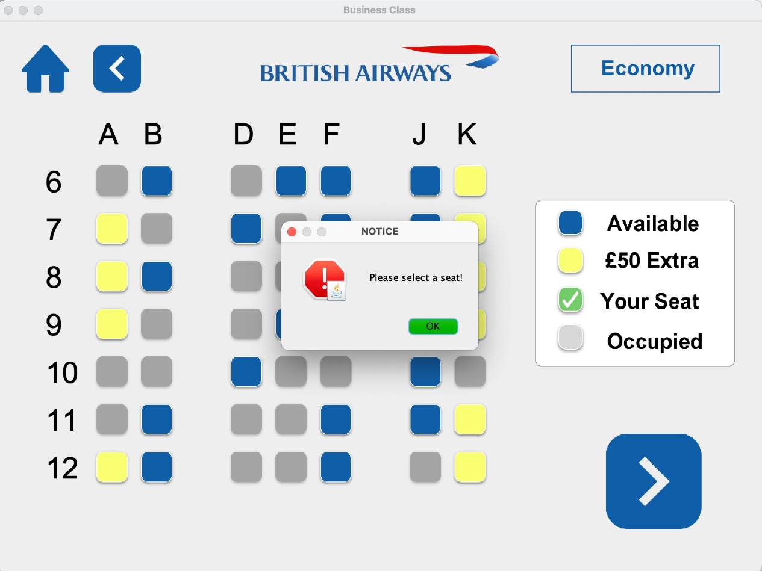

5. Option

You can choose free meals, such as standard, vegetarian and halal, according to your dietary habits. Additional value-added options are also available and the total amount can be displayed after clicking on calculate.

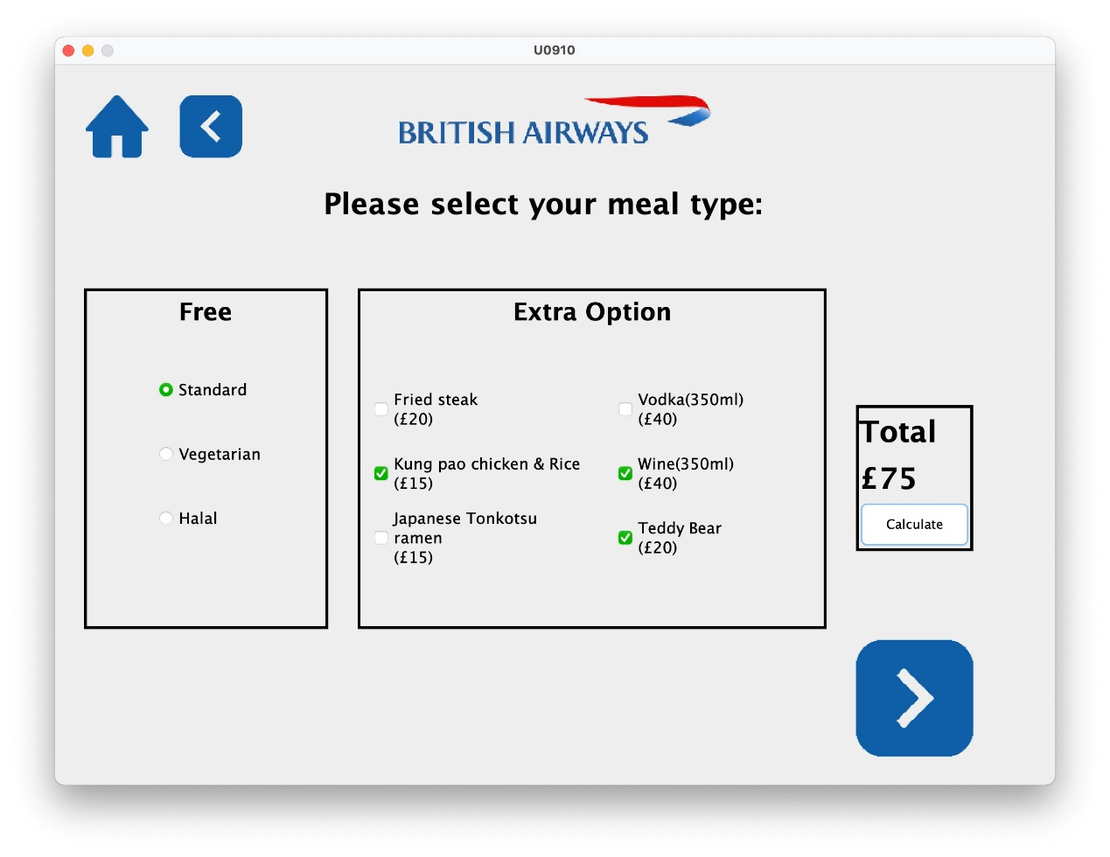

6. Payment Method Options

You have three ways to complete your payments: credit card, master card and Paypal.

7. Payment

Depending on the payment method you choose, You can pay by entering your email address, card number and the correct CVV, or enter your Paypal account and password.

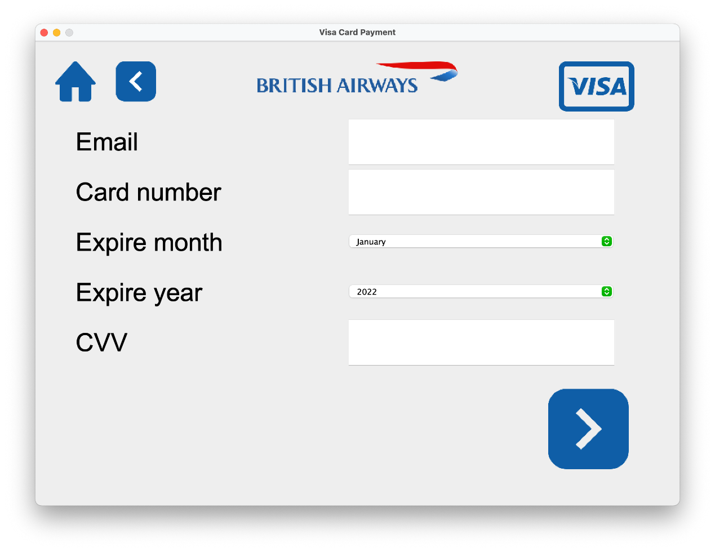

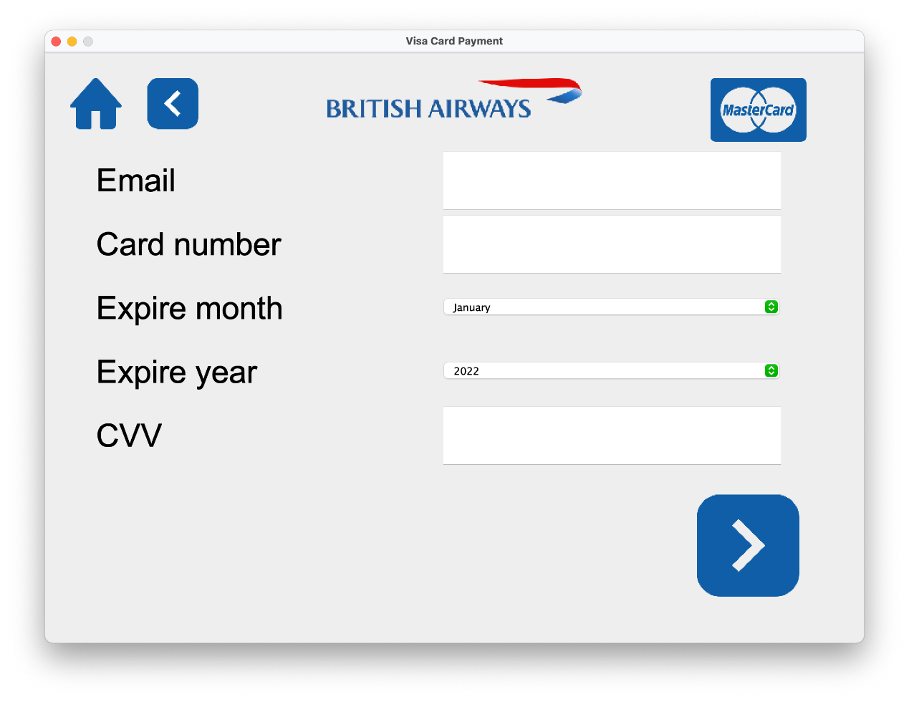

8. Print

If reserved when booking, all materials including boarding pass, baggage tag and baggage ticket would be printed.

飞机在飞行

飞机在飞行

